* Navigation bar:



There is a DiamondCut Motors logo consisting of text and an image, clicking on which will open the home page. There are menu items such as home, cars, showroom, about us, and login. Clicking on home will open the home page, clicking on cars will open the cars page, clicking on showroom will open the showroom page, clicking on about us will open the about us page, and clicking on login will open the login page.

* Footer:

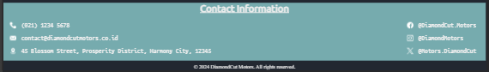

There is information regarding phone number, email, location, and names of social media accounts.

* 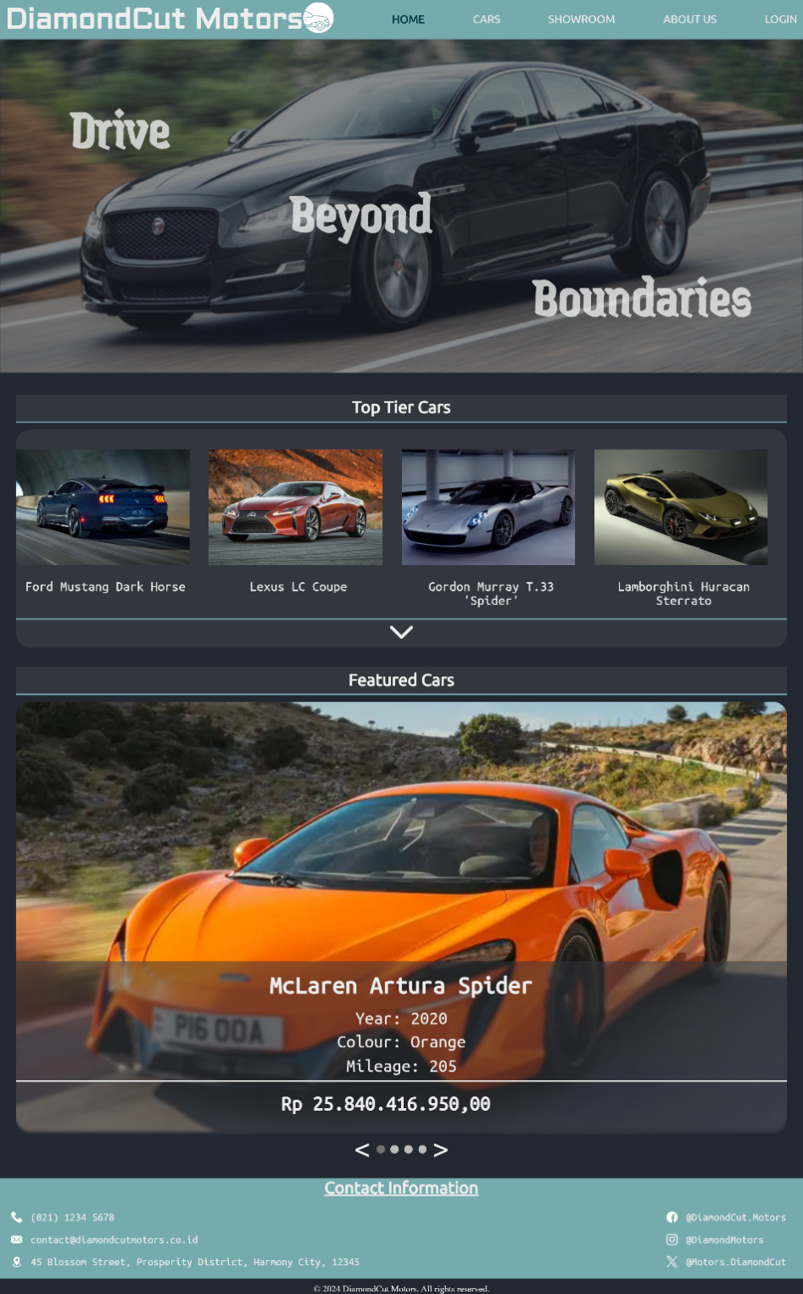Home page:

There is a tagline that reads "Drive Beyond Boundaries" with a background photo of a car. Below it, there is a gallery containing a total of 8 photos. However, initially only 4 photos are displayed along with a drop-down button. When the drop-down button is clicked, it will display another 4 photos, and the drop-down button will change to a close button, which will close the additional 4 photos and revert back to displaying only 4 photos. Below the gallery, there is a carousel containing 4 photos displayed one by one. The previous and next buttons are located below the carousel, and there are also 4 small circles located in the middle between the previous and next buttons. These circles indicate which page is currently being displayed.

* A screenshot of a cell phone

  Description automatically generatedCars Page:

Displaying used cars and new cars, both of which have the text "see more" at the bottom. When this text is clicked, each "see more" will display a page containing many used cars and new cars.  
Displaying logos of partner car brands. These logos are displayed in a carousel with an infinite loop.

* 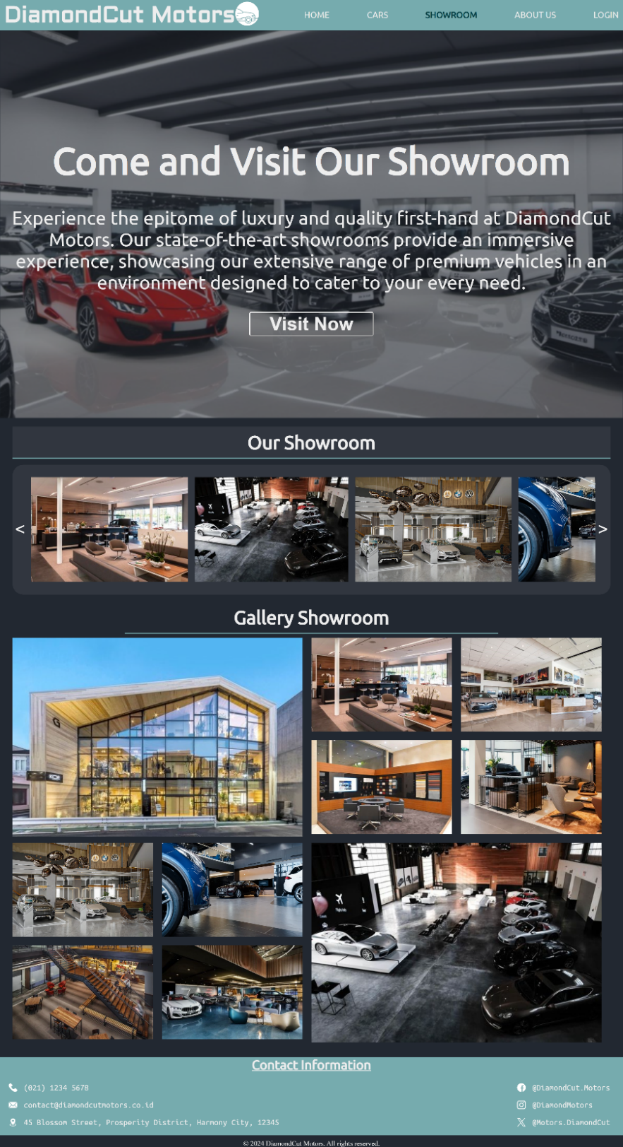Showroom page:

Displaying a jumbotron consisting of a showroom photo and inviting text encouraging users to visit the showroom. Below the text, there is also a button "visit now" which will display Google Maps location of the showroom when clicked.

Displaying a showroom slider containing several photos of the showroom. When the previous and next buttons are clicked, the display will shift to the next set of photos.

Displaying a gallery of showroom photos. The slider can also be swiped to shift images without clicking the previous and next buttons.

* A screenshot of a computer

  Description automatically generatedAbout us page:

Displaying history, vision, and mission sections along with logos for Instagram, Facebook, and X. When these logos are clicked, they will open DiamondCut Motors' social media accounts.

* A screenshot of a computer

  Description automatically generatedLogin page:

Displaying the DiamondCut Motors logo on the left side and five input boxes on the right side for user input. Users are prompted to input their username, email, phone number, password, and confirm password.  
If any input box is left empty and the user clicks login, an alert will appear informing the user that all boxes must be filled in first.  
If the user types an email in the email input box but does not end it with "@gmail.com", an alert will appear asking the user to add "@gmail.com".  
If the user types a phone number that does not start with 0 in the phone number input box, an alert will appear telling the user that the phone number must start with the number 0.  
If the password and confirm password entered do not match, an alert will appear informing the user that the password and confirm password do not match.

<https://www.caricos.com/cars/a/aston_martin/2021_aston_martin_dbx_satin_xenon_grey/images/186.html>

<https://www.autoevolution.com/news/startechs-new-bentley-continental-gt-shows-posh-interior-132774.html>

<https://www.thedrive.com/news/41417/2022-bentley-flying-spur-hybrid-536-hp-combined-from-an-electrified-v6>

<http://bay2car.com/Bentley-Continental-6-0-GTC-auto-2006-56-reg-Convertible-301898678986/car97776>

<https://www.newsbytesapp.com/news/auto/bmw-is-aiming-for-higher-ev-sales-in-2024/story>

[Albany Auto Show Manufacturers and Exhibitors | Albany Auto Show (albanyautoshows.com)](https://albanyautoshows.com/manufacturers-and-exhibitors/)

<https://www.pinterest.com/ehsansona/car-showroom-design/>

<https://www.drive.com.au/news/drop-top-ferrari-812-spider-in-the-works/>

<https://www.focus2move.com/italian-autos-market/>

<https://www.next-brands.com/en/ferrari/>

<https://www.motusselect.co.za/blog/understanding-vehicle-valuation>

<https://motor-junkie.com/these-are-the-best-cars-set-to-come-out-in-the-next-five-years/63170/>

<https://www.behance.net/gallery/113854657/-CAR-SHOWROOM-DESIGN>

[Gordon Murray Automotive T.33 specs, performance data - FastestLaps.com](https://fastestlaps.com/models/gordon-murray-automotive-t-33)

[Top Gear’s top 23 cars of 2023 | Top Gear](https://www.topgear.com/car-news/best-2022/top-gears-top-23-cars-2023)

<https://www.ongsono.com/go/44614b44af4bda429cb7a5b068fb718b/lamborghini-emblem.html>

<https://carbuzz.com/news/lexus-creates-new-blue-paint-that-s-more-blue-than-anything-seen-before/>

<https://www.pngall.com/lexus-png/download/99859>

<https://www.automotiveworld.com/news-releases/porsche-dealerships-receive-worldwide-new-corporate-architecture/>

[Classic Car Club Manhattan (revelr.com)](https://www.revelr.com/vendor/classic-car-club-manhattan)

<https://robbreport.com.my/2021/08/11/mercedes-g-wagen-amg-g63-luxury-vehicle/>

<https://stufnews.com/apprenticeships/mercedes-benz-apprenticeship-programme-2021-2022/>

<https://fmwhat.online/top-10-luxury-cars-in-2023/>

<https://freelogopng.com/porsche-logo-png>

<http://www.antpham.com/precision-toyota-dealership>

<http://www.motorverso.com/exploring-rolls-royce-ghost-black-badge/>

<https://www.motortrend.com/reviews/2023-rolls-royce-phantom-ghost-black-badge-quick-drive-review/>

<https://caredge.com/rolls-royce/depreciation>

<https://www.scmp.com/presented/lifestyle/topics/customer-centric-luxury/article/3035911/bmws-new-flagship-showroom>

<https://www.pinterest.ph/pin/422281208963562/>

<https://pin.it/2XT1saDGW>

['Porsche' Center -Construction | GRAVITA | Gravita Constructions](https://gravita.ge/en/project/porsche-center-reconstruction)

[Precision Gear Measurement for Master Gears, Spline Gages (slonegear.com)](https://slonegear.com/)

<https://ipesingcimena.blogspot.com/2020/02/top-80-of-johnson-controls-interior.html>

<https://wallpapercave.com/jaguar-xj-wallpapers>

<https://www.motortrend.com/news/elon-musk-tesla-cybertruck-float-water-claim-twitter/>

<https://publicdomainvectors.org/en/free-clipart/User-icon-picture/44928.html>

<https://www.labotronics.com/>

<https://svgsilh.com/image/885495.html>

<https://www.flaticon.com/free-icon/arrow-down-sign-to-navigate_32195?term=drop+down&page=1&position=1&origin=search&related_id=32195>

[Eye - Free medical icons (flaticon.com)](https://www.flaticon.com/free-icon/eye_159604)

<https://www.onlinewebfonts.com/icon/389063>

<https://www.flaticon.com/free-icon/door-key_386295>

<https://icon-library.com/icon/lock-png-icon-18.html>

<https://www.flaticon.com/free-icon/phone-call_319329>

<https://www.svgrepo.com/svg/479854/magnifying-glass-8>

<https://www.freepik.com/free-icon/user-shape_744409.htm>

<https://www.flaticon.com/free-icon/profile-user_64572?term=account&page=1&position=16&origin=search&related_id=64572>

<https://www.flaticon.com/free-icon/email_542689?term=email&page=1&position=2&origin=search&related_id=542689>

<https://www.flaticon.com/free-icon/facebook_1384005?term=facebook&page=1&position=2&origin=search&related_id=1384005>

<https://www.flaticon.com/free-icon/instagram_1384031?term=instagram&page=1&position=5&origin=search&related_id=1384031>

<https://www.flaticon.com/free-icon/location_535239?term=location&page=1&position=2&origin=search&related_id=535239>

<https://www.flaticon.com/free-icon/phone-call_597177?term=phone&page=1&position=4&origin=search&related_id=597177>

<https://www.flaticon.com/free-icon/twitter_5968958?term=x&page=1&position=6&origin=search&related_id=5968958>